

GA10004 – Information Systems Development **Assignment 2**

* Oliver Holden -

Table of Contents

Introduction 3

Case study description 3

1a – Database design and OOP 3

(i) 3

(ii) 4

(iii) 4

1b – HTML & CSS 5

(i) 5

2 – Source control 6

1) 6

References 8

Appendix 9

1a 9

1b 9

# Introduction

Throughout this assignment we will investigate database design, html and CSS (with a touch of JavaScript), and a look into git and its version control abilities. The majority of examples shown come from my own personal knowledge, but references have been made to the corresponding sources where deemed appropriate.

Although keeping to a basic level in each discipline I hope the intention of this report succeeds in providing a good overview of the capabilities of each topic and can persuade others to learn the art of each as a skill for the future as this is a passion, I hold myself.

# Case study description

Consider for a moment that you are an administrator at a school and that it is your job to compile the personal information of the students and store it in paper files. In the office, you can find a Student Personal Profile (SPP) form to fill out. When a student is accepted into a program, he or she is required to report to the departmental office of that program to provide personal information such as their student id, first name, middle name, last name, gender, age, the department to which they were admitted, the year in which they were admitted, and so on.

# 1a – Database design and OOP

## 

From the details provided in the case study, the database design would need to be relational rather than flat file, meaning that there will need to be multiple tables interacting with each other through foreign key relationships in order to efficiently fulfil the requirements for this system. In addition to a table dedicated to students we would be required to hold information on the individual courses themselves that each student is enrolling onto; this would include information such as: the number of students registered to the course, the starting/ end date for the class, the assigned course code, and the lecturer assigned to the class. There would also be a need here for a third table dedicated to each lecturer under employment of the school, much like the student table.

## (ii)

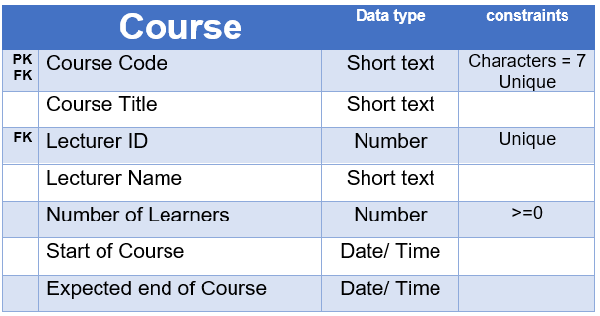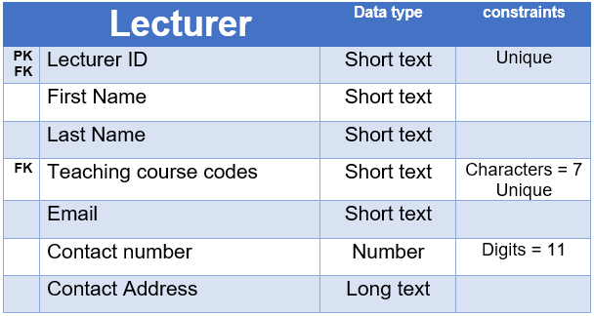

,

Figure - Entity relationship diagram for additional student tables

## (iii)

Within the zipped folder submitted for this assignment is my simple representation of a student database (Student.accdb) showing example fields and a suggested relationship between both the Student and Student details tables. Screenshots showing these features can be seen below.

Figure - The student table with example data

Figure - The student details table with example data

Figure - Relationship diagram between the two tables shown in figures 2 and 3.

# 1b – HTML & CSS

## (i)

As above with the student database, my webpage is saved within the zipped file submitted for this assignment under “Student intake form.html”. This webpage is designed to intake basic information for a student starting with the university of Dundee before course details are discussed. The information gathered is only to hold data directly concerning the student personally; their name, date of birth, contact information including a phone number and address, and a nominated emergency contact in the case of extreme circumstances where one has need to be contacted in place of the student. This intake form also holds contact information for the university of Dundee displaying all information in an attractive UI complete with a page header. The screenshot below has been taken from Microsoft edge version 111.0.1661.54 at 90% zoom.

Figure - Student intake form site (MS Edge)

# 2 – Source control

## 1)

Version control, commonly also known as source control is described as “the practice of tracking and managing changes to software code” (Atlassian, 2023). In simple means, it is a feature included in applications which allow users to save ‘versions’ of their work as backups, allowing them the option to revert back to a previous state in the case the most up-to-date version is for some reason deemed unusable. Version control also allows users to track all authors activities, tracking changes of any kind.

In an organizations case, version control would be crutial for documentation, especially in larger files such as databases where lost data may be impossible to recover. Having the ability to rewind time to a point you know is uncorrupted would be instrumental in proventing catastrophic losses with the potential of financially and operationally crippling a business.

Version control doesn’t even require internet access in order to function, although a loss of network does mean an inability to collaborate with other authors, locally, you would still have all the same benefits (minus pushing/ pulling versions to sync with other collaborators). For an organization this means that no matter where an employee is, they are able to make meaningful contributions of work without the worry of causing damage or having contributions rendered useless upon their return as long as there is adequate communication beforehand to discuss what work should be done (so that additions arent duplicates as this may cause issues when syncing)

All of the features of version/ source control are put in place to increase the effectiveness and overall efficiency of a project or piece of work, especially in a collaborative context where many authors are able to contribute to success. Problems can be found much quicker and bugs can be avoided through reverting to an error free version where the errors did not exist. Saved time with no decrease in quality of work is an ideal scenaro for anyone regardless of industry.

A final benefit to look at which is vital for organizations is their adherence to laws and compliance with them. Laws set through governing bodies as well as internal company proceedures. Being capable of tracking changes made can ensure the content and data is being used correctly, in the case of GDPR especially for the UK, any piece of work making use of peoples personal data must be handled with extreme care and being able to track the authors who have access to the file could mean avoidance of legal action as well as reputational and financial penalties.

## 2)

# Conclusion

Each area of interest that has been discussed here has only been looking at the basics and so if you do find yourself interested in learning more I would certainly recommend further research. For databases with a beginner Microsoft access (provided as part of the Microsoft office package) is a perfect first application to learn as this will help to teach all the basics that you will need to know along with capabilities to incorporate SQL queries for a more complex knowledge. If web development and HTML/ CSS coding is where you find an interest, then I would recommend looking into W3Schools as an online source of information and extensive learning possibilities covering all areas. Finally, version control and git can only be GitHub for your source of learning, this is a site that is used universally among all forms of programmers and IT professionals and so there is a lot of online information sources to help you get started here.

If you don’t have a desire for further learning then I hope what you have read here has been of some use, even as an entry level of knowledge these areas of interest effect you ever day of your life, working in the background without your knowledge

# References

Atlassian, 2023. *What is version control?.* [Online]   
Available at: https://www.atlassian.com/git/tutorials/what-is-version-control#:~:text=Version%20control%2C%20also%20known%20as%20source%20control%2C%20is,teams%20manage%20changes%20to%20source%20code%20over%20time.  
[Accessed 31 03 2023].

# Appendix

## 1a

Access to my example use database can be found in the provided zip file under “Student.accdb”. This database consists of two tables with a single simple relationship connecting the two. Please note that all data included in this database is fictional and so names, phone numbers and address data do not correspond with each other and should not be used in a real-world context.

## 1b

My html and CSS project can be found under “Student intake form.html”, this project was coded using intellij IDEA community edition 2022.2.3 viewing the page through Microsoft edge. However, all browsers should work. The page is only a template and so data entered into the provided form is not sent to any logging database, the page is limited in functionality to its visuals.